Project – 2
TrendStore

- Git Clone:
- Docker:
- Dockerized the application by creating Dockerfile: 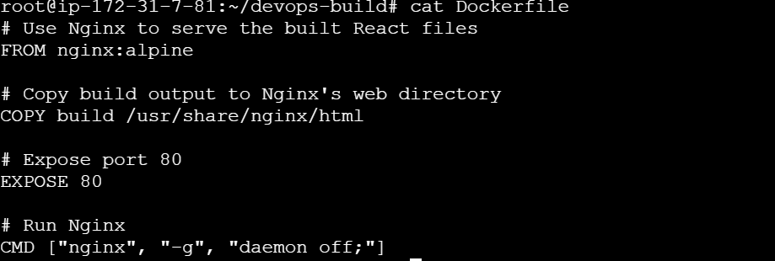
- Build the images by using the command:
docker build -t trend-app : 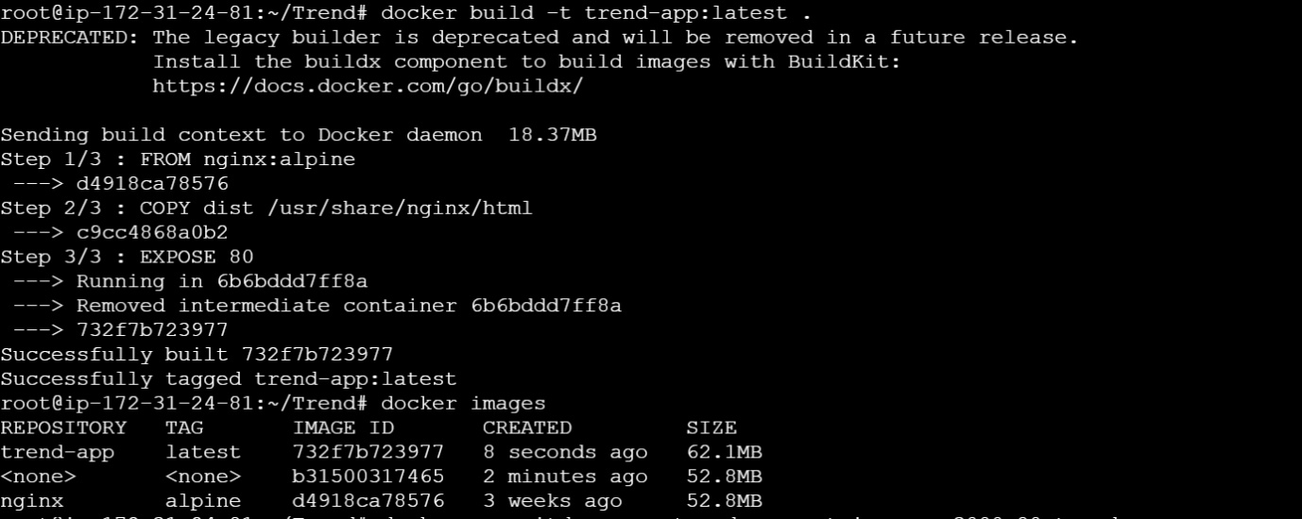
docker run -itd –name trend-app container -p 3000:80 trend-app : 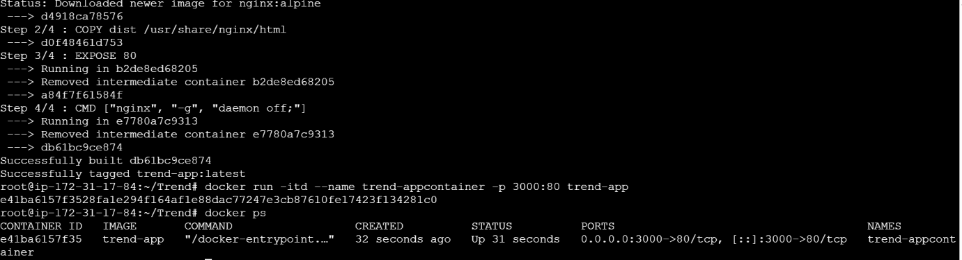
- Output :
- Terraform:
- Instead of manually creating a VPC, EC2, or IAM users, we use Terraform, which lets us write all the resources as code. With a few commands like terraform init, terraform plan, and

- init prepares Terraform, plan shows what it will do,
- Terraform Plan
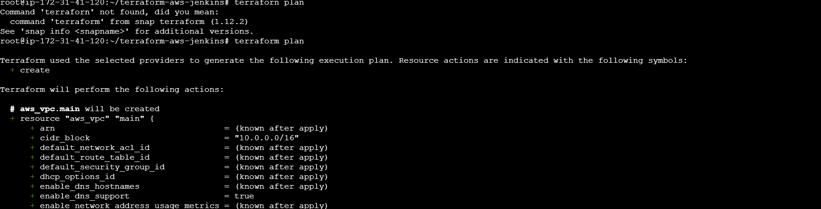
- Terraform apply actually provisions the resources. 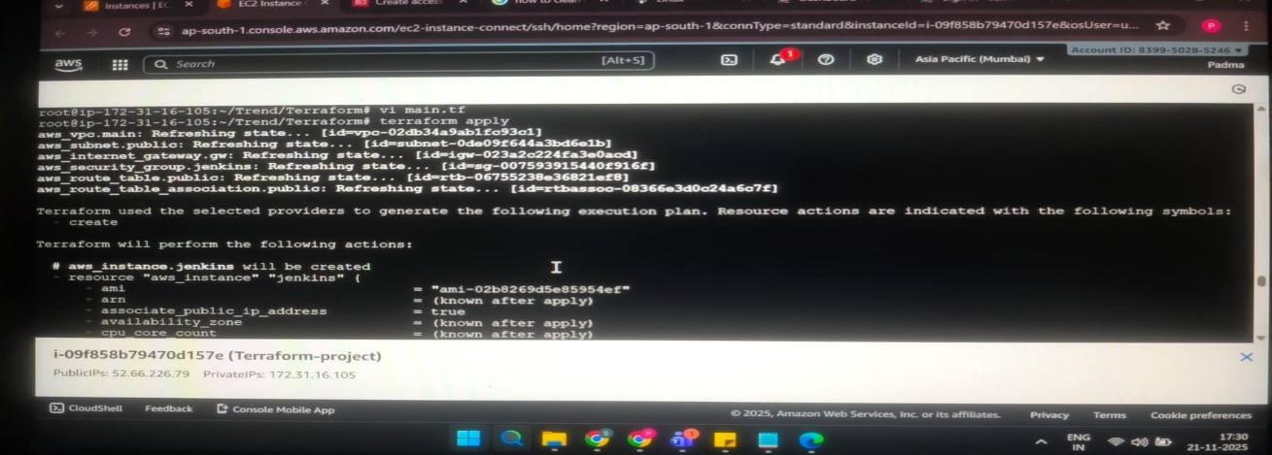
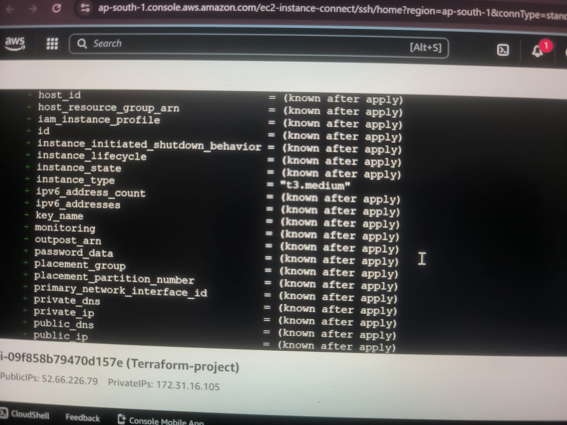
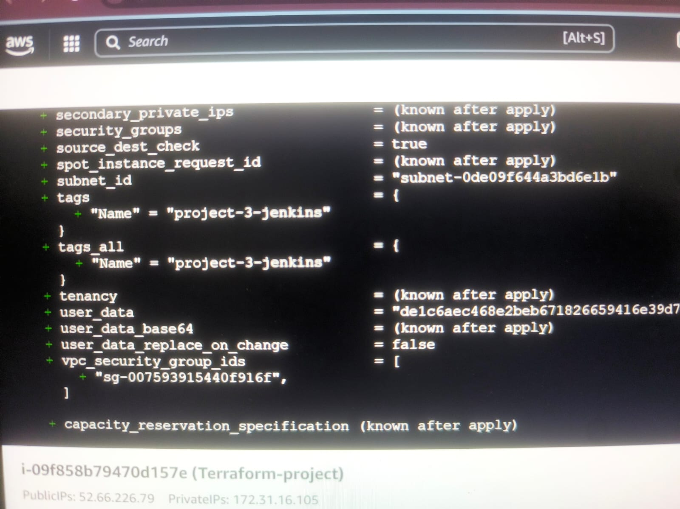

- Main.tf 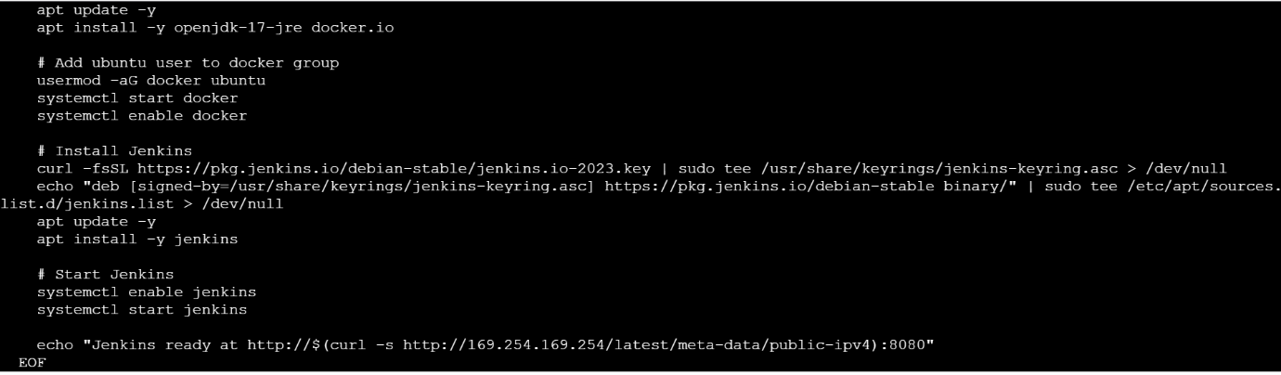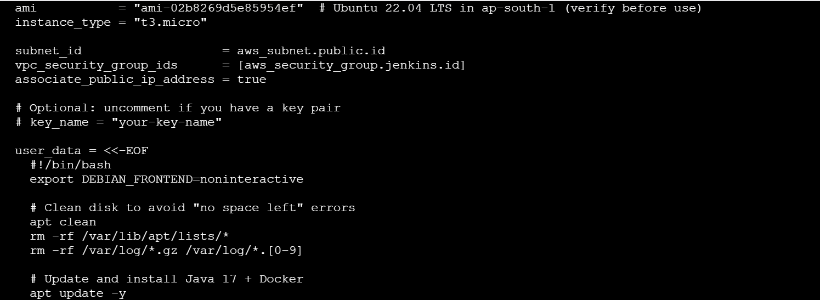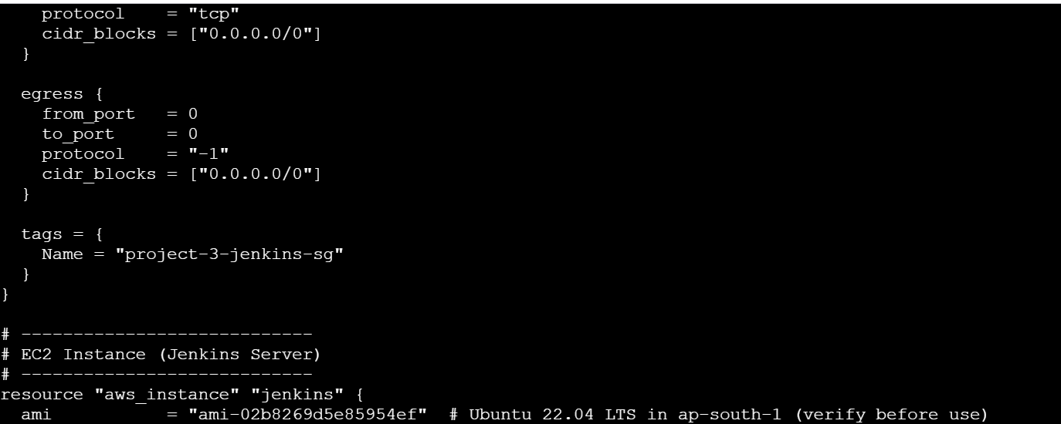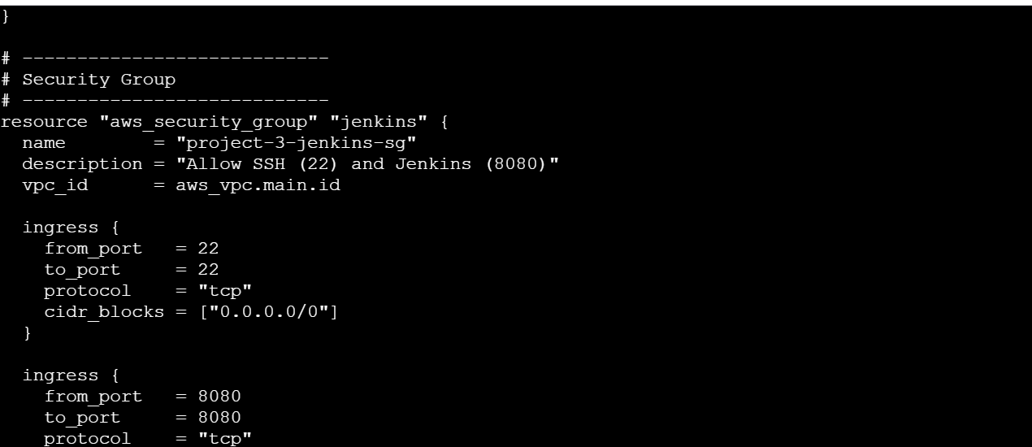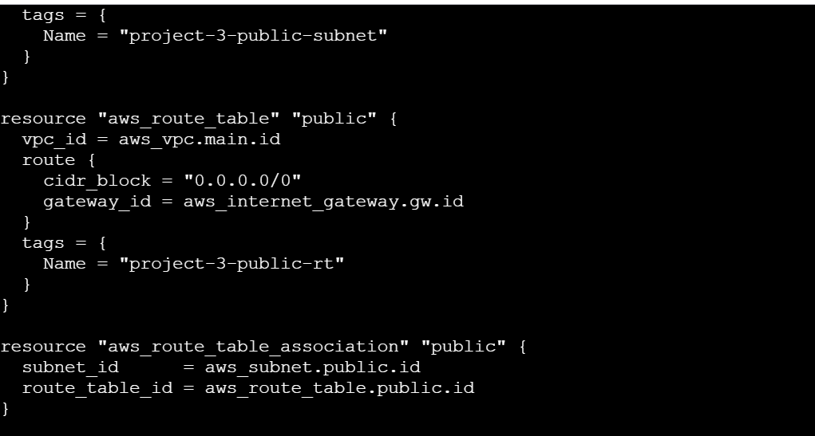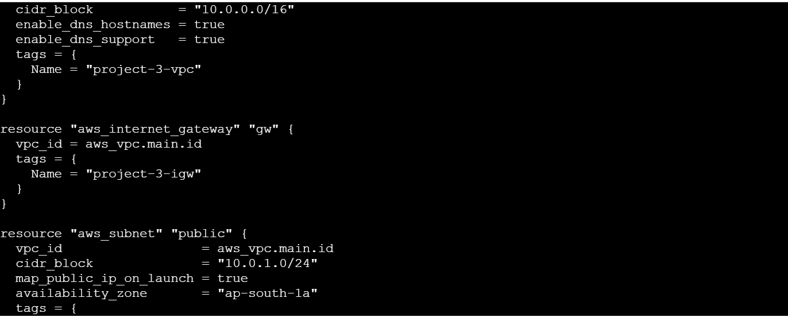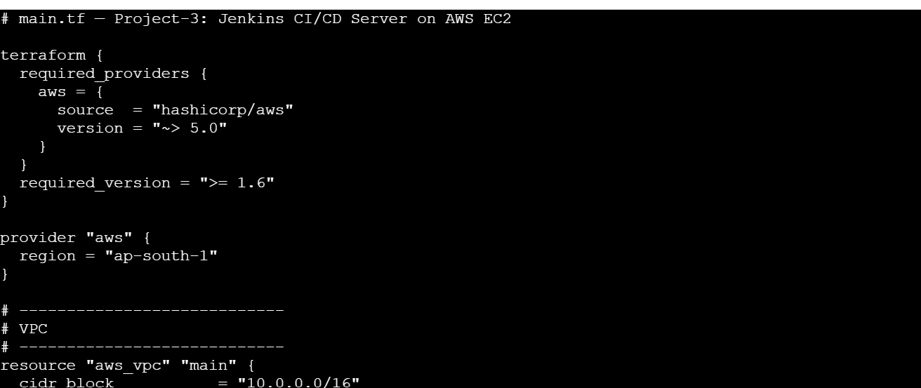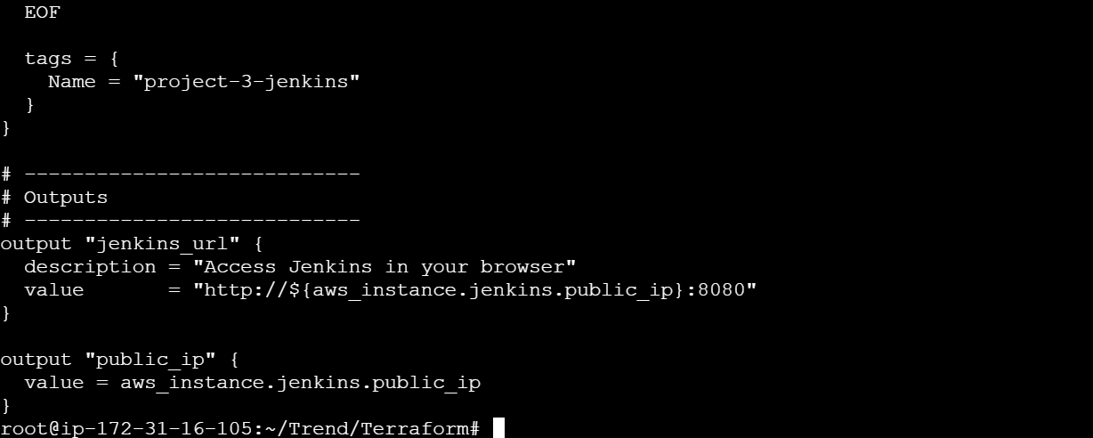

- DockerHub: 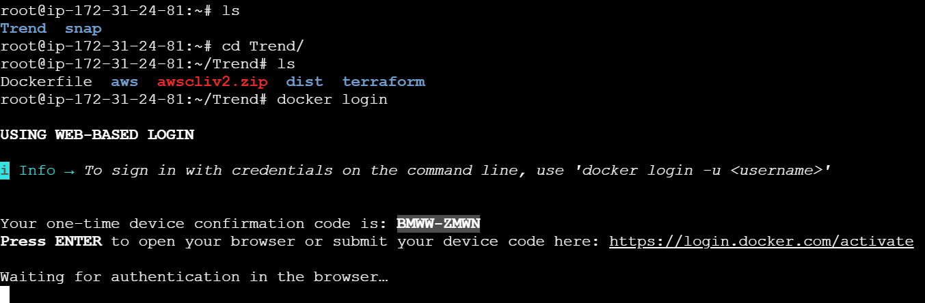
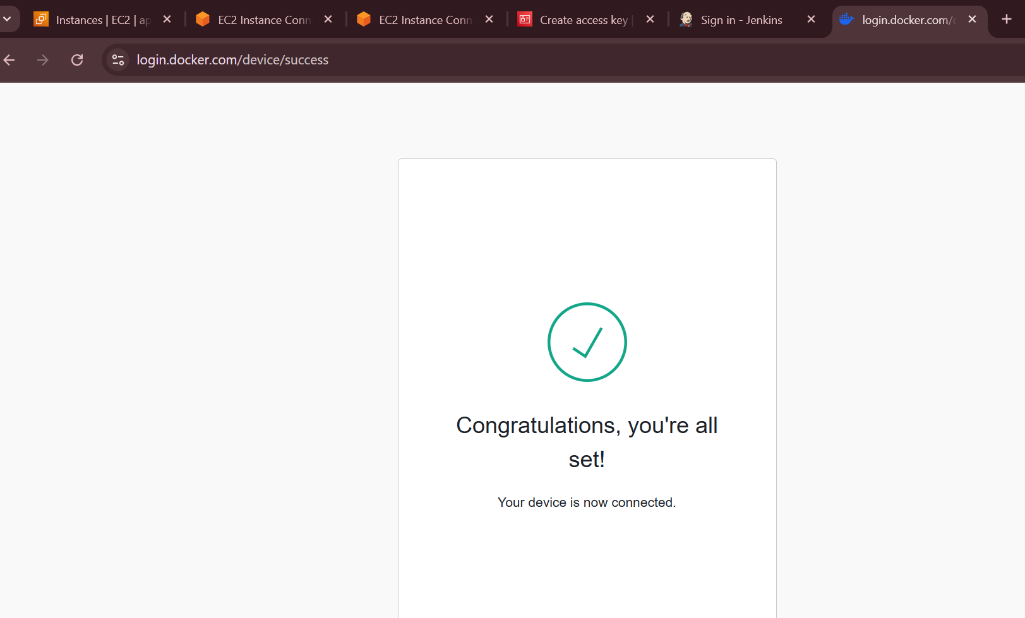
- Tagged and pushed the images by below commands:
docker tag trend-app:latest <saidoc540>trend-app:latest
docker push <saidoc540>/trend-app:latest
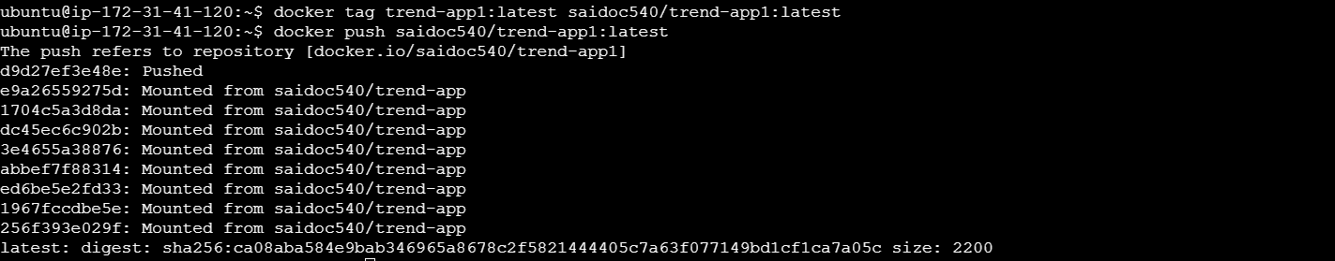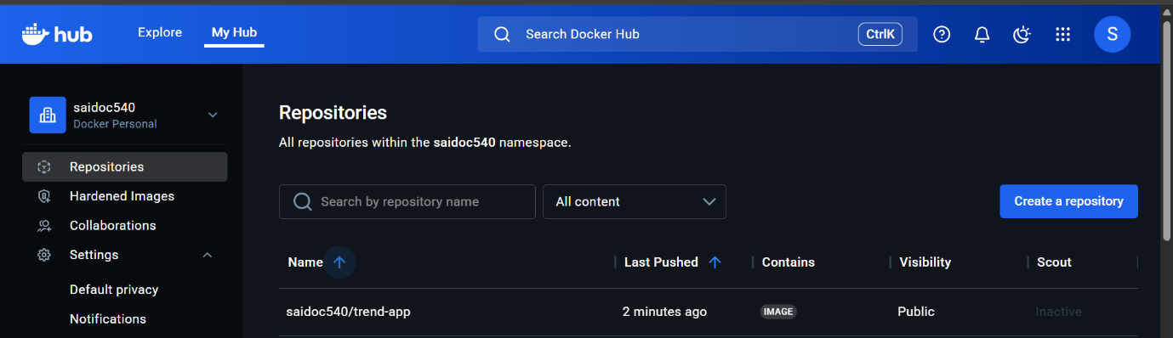

- Kubernetes:
Step - 1 : Creates EKS Management Host in AWS ,
- Connected to machine and installed kubectl using below commands.
curl -o kubectl https://amazon-eks.s3.us-west-2.amazonaws.com/1.19.6/2021-01-05/bin/linux/amd64/kubectl
chmod +x ./kubectl
sudo mv ./kubectl /usr/local/bin
kubectl version --short –client
- Installed AWS CLI latest version using below commands:
sudo apt install unzip
curl "https://awscli.amazonaws.com/awscli-exe-linux-x86_64.zip" -o "awscliv2.zip"
unzip awscliv2.zip
sudo ./aws/install
aws –version
- Install eksctl using below commands:
curl --silent --location "https://github.com/weaveworks/eksctl/releases/latest/download/eksctl_$(uname -s)_amd64.tar.gz" | tar xz -C /tmp
sudo mv /tmp/eksctl /usr/local/bin
eksctl version
- Created IAM role & attached to EKS Management Host:
- Created EKS Cluster using eksctl: 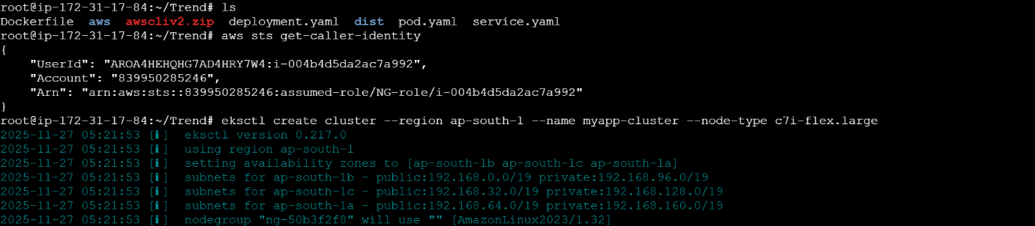
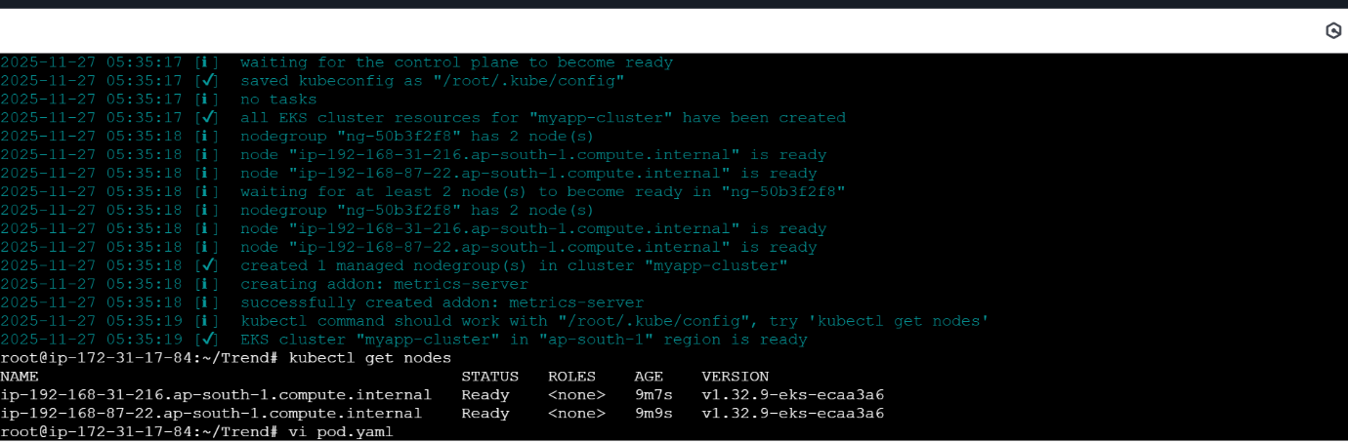
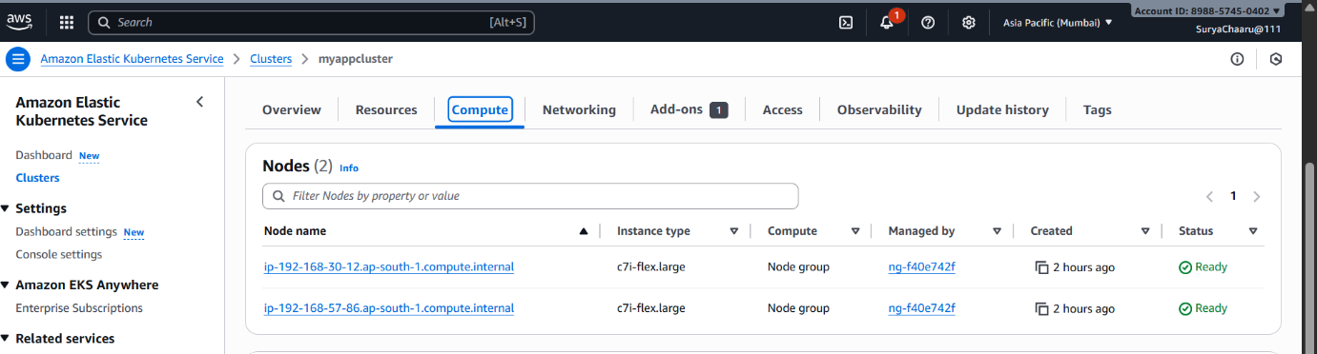
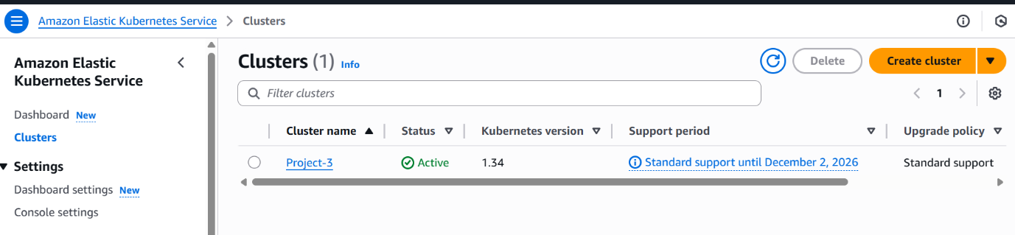
- Created POD.yaml file 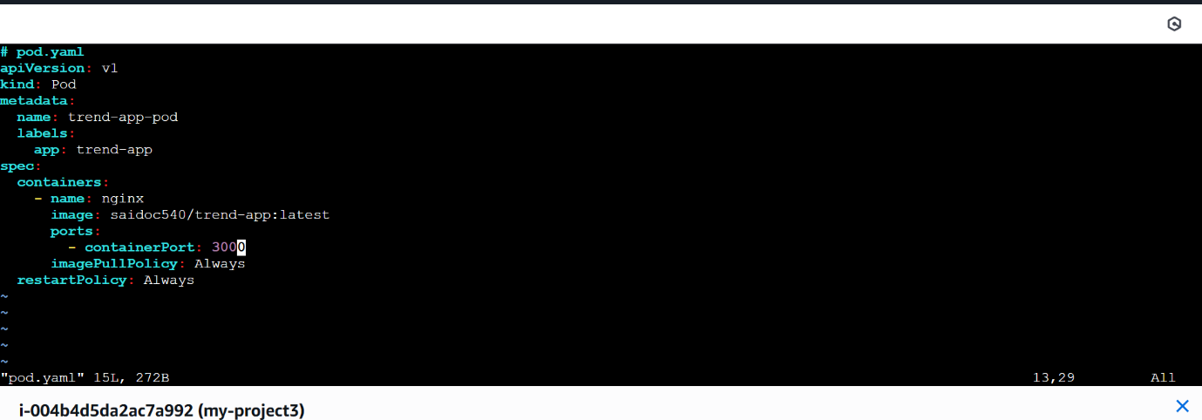
- Deployment and Service YAML files. 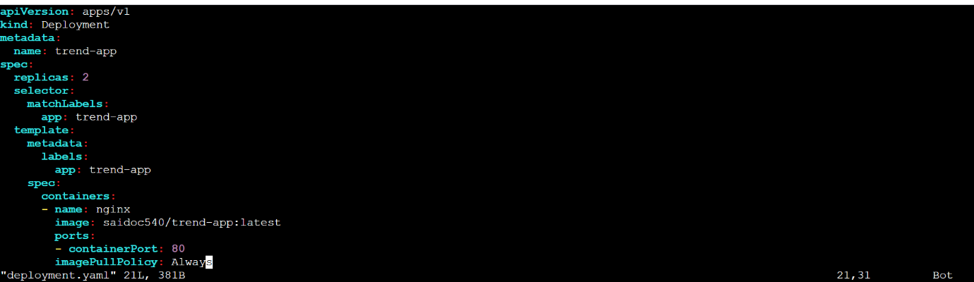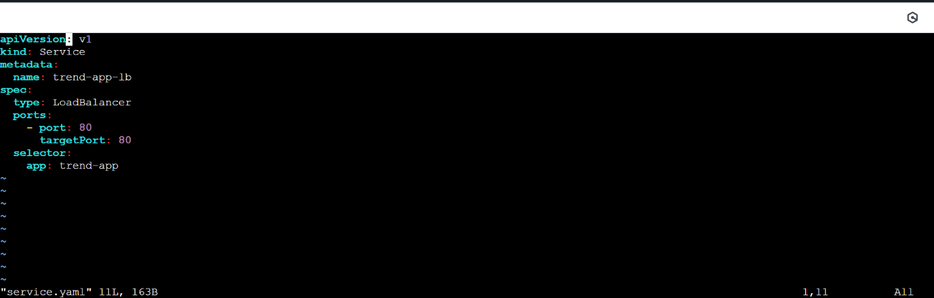
- Commands used
kubectl apply -f deployment.yaml
kubectl apply -f service.yaml
kubectl get pods
kubectl get svc 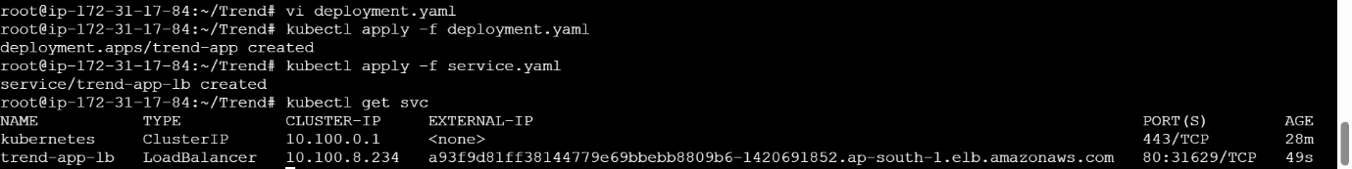
- OutPut: 

- Version Control:
- .gitignore and .dockerignore files
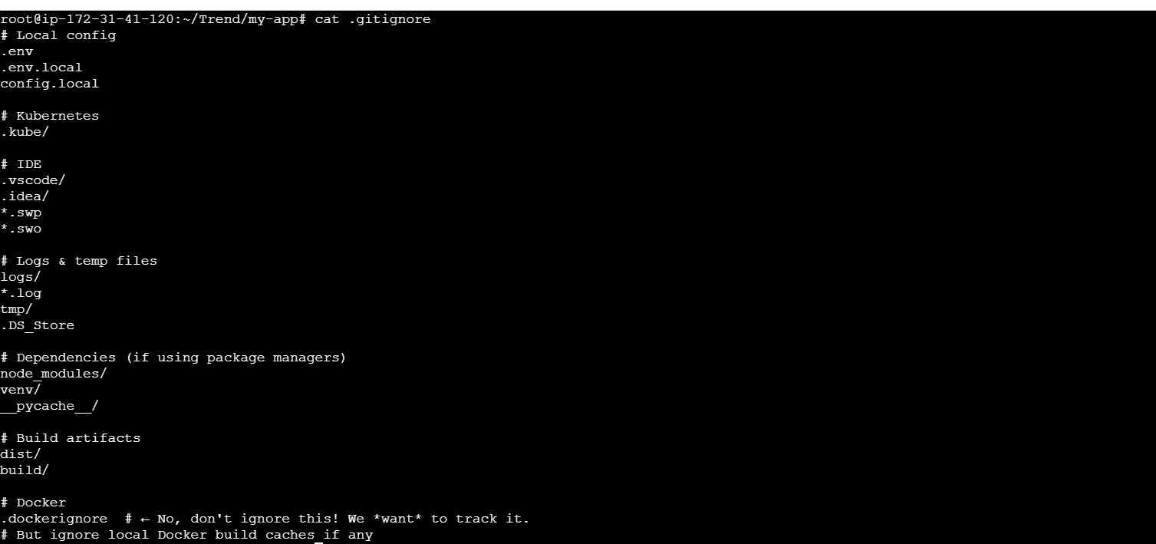
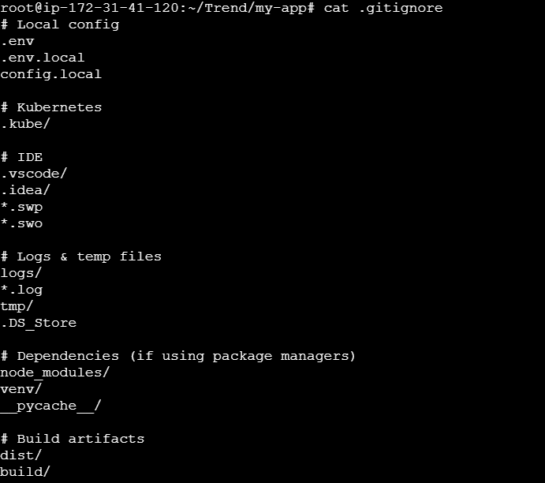
git add .
git commit -m "Initial commit with Docker & Kubernetes setup"
git remote add origin https://github.com/Bhuvisai22 /Trend.git
git remote add origin https://github.com/Bhuvisai22/ Trend.git
git remote add origin https://github.com/Bhuvisai22/ Trend.git
git push -u origin main
git remote add origin https://github.com/Bhuvisai22/Trend.git 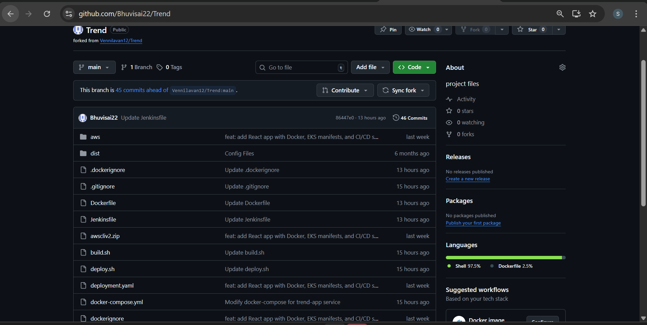
- Jenkins:

- Installed Jenkins
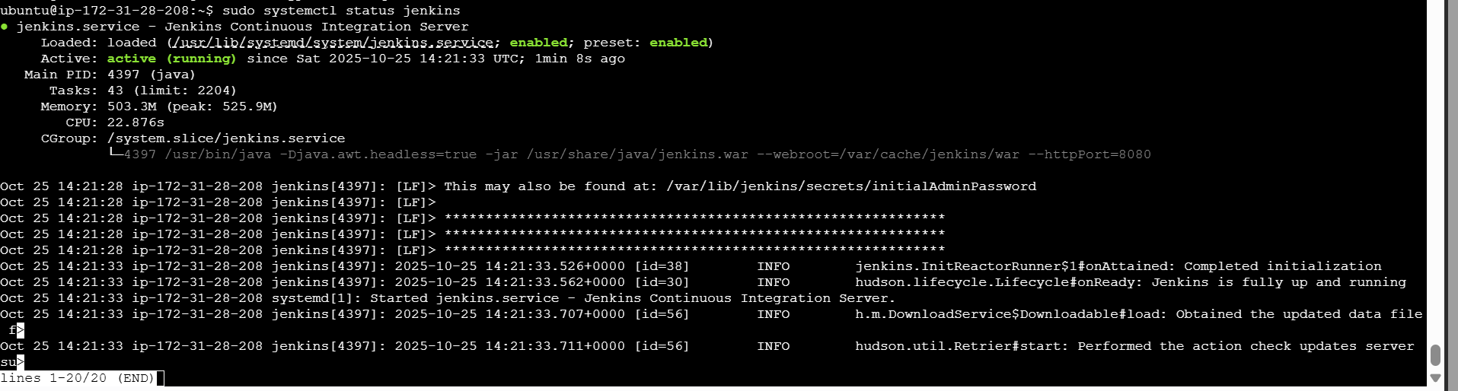
Configured to GITHUB 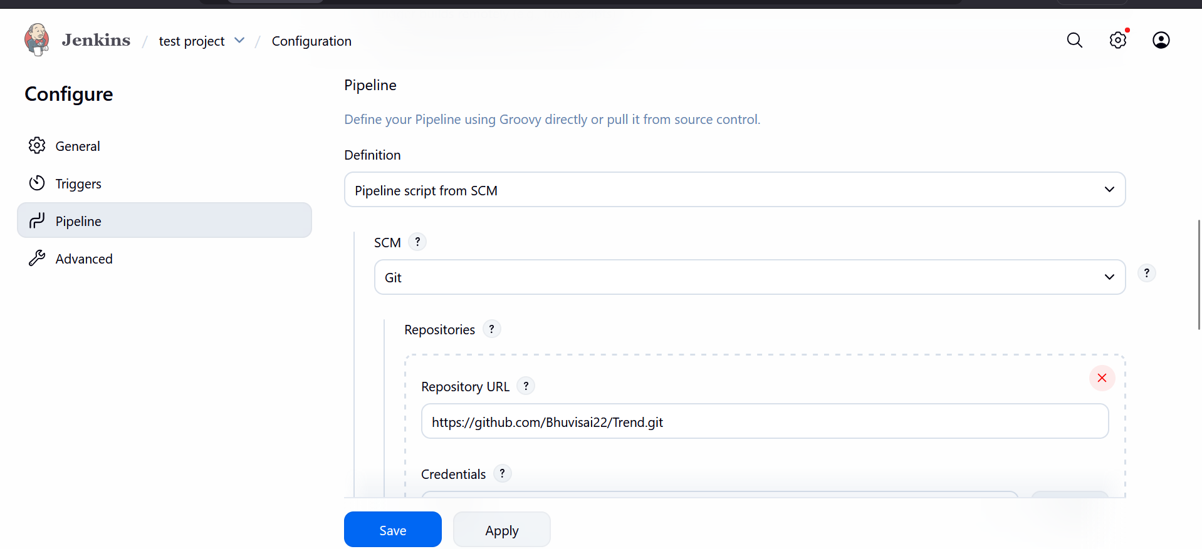
Deployed the application: 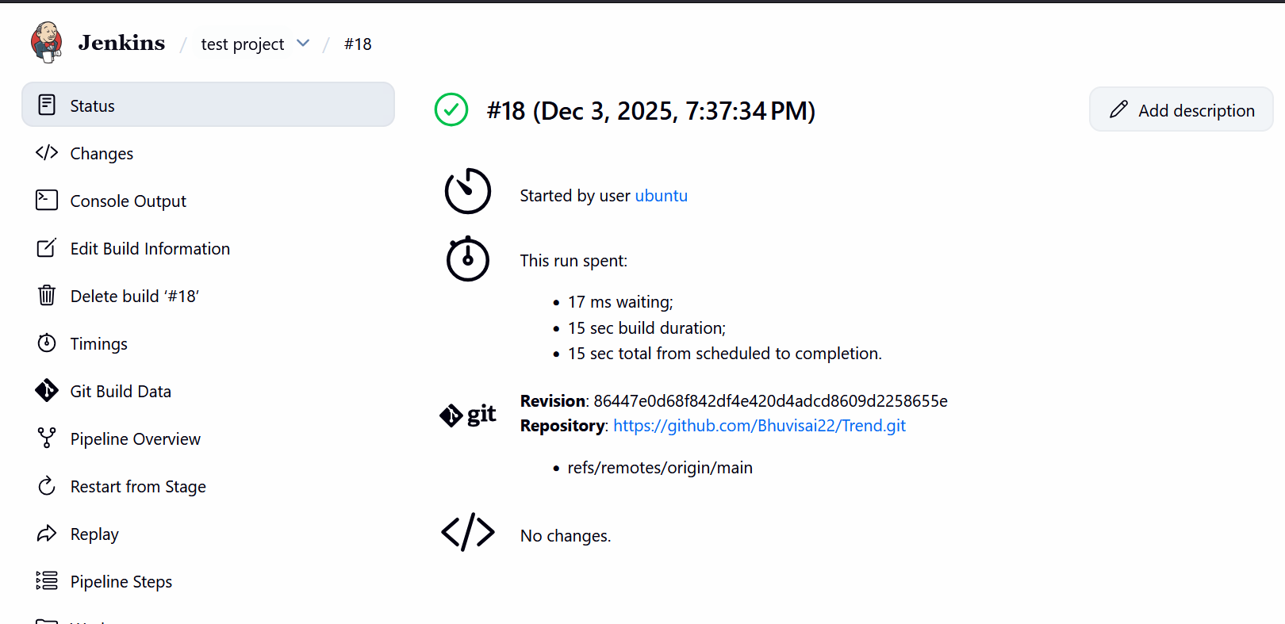
Console Output: 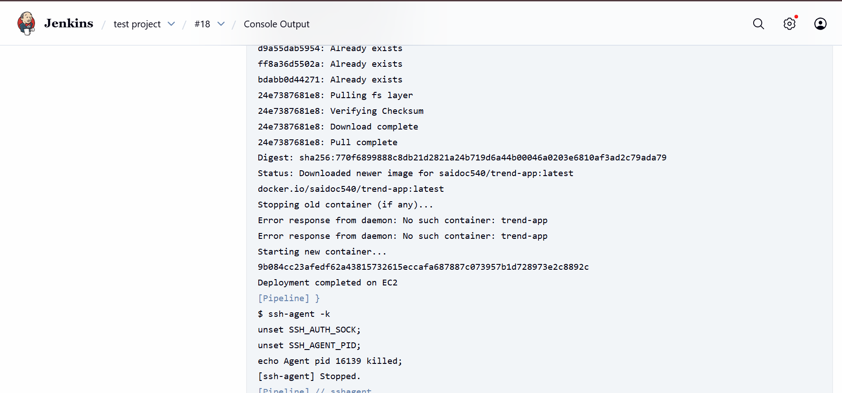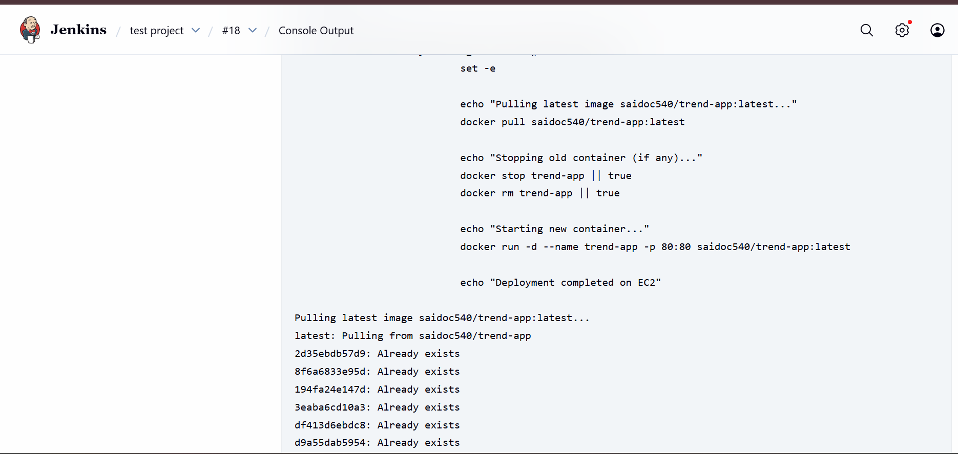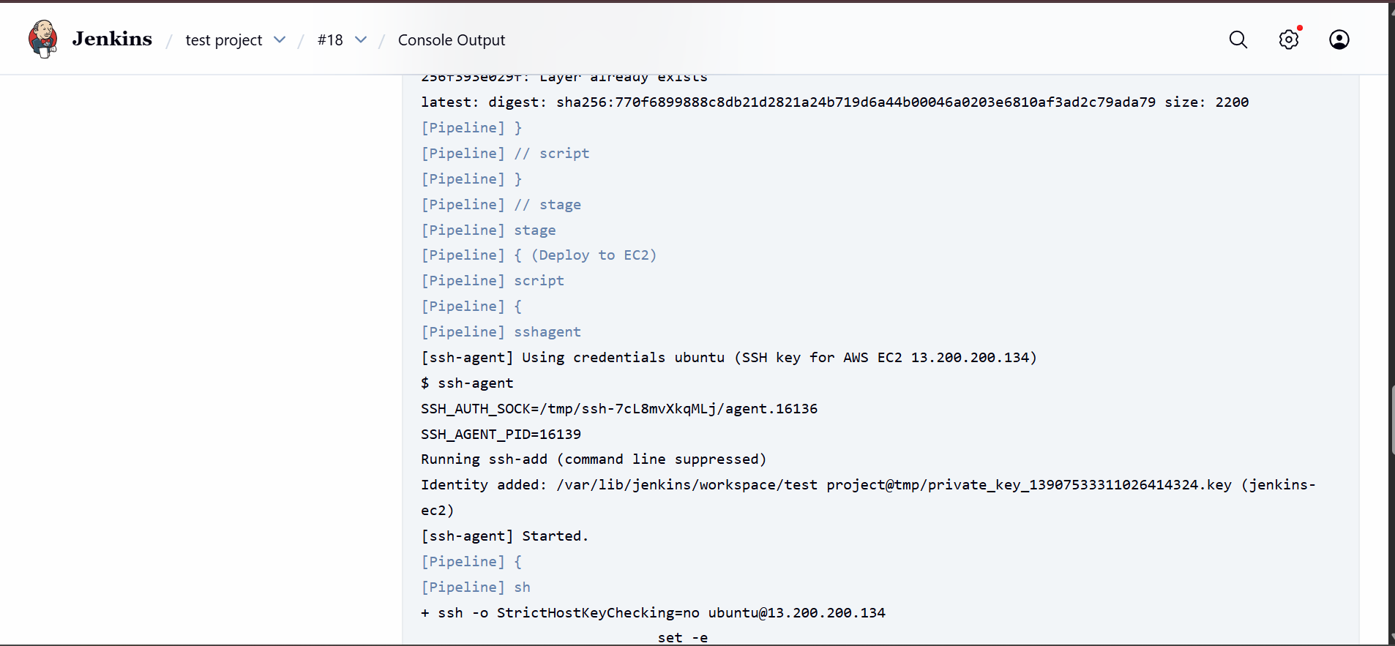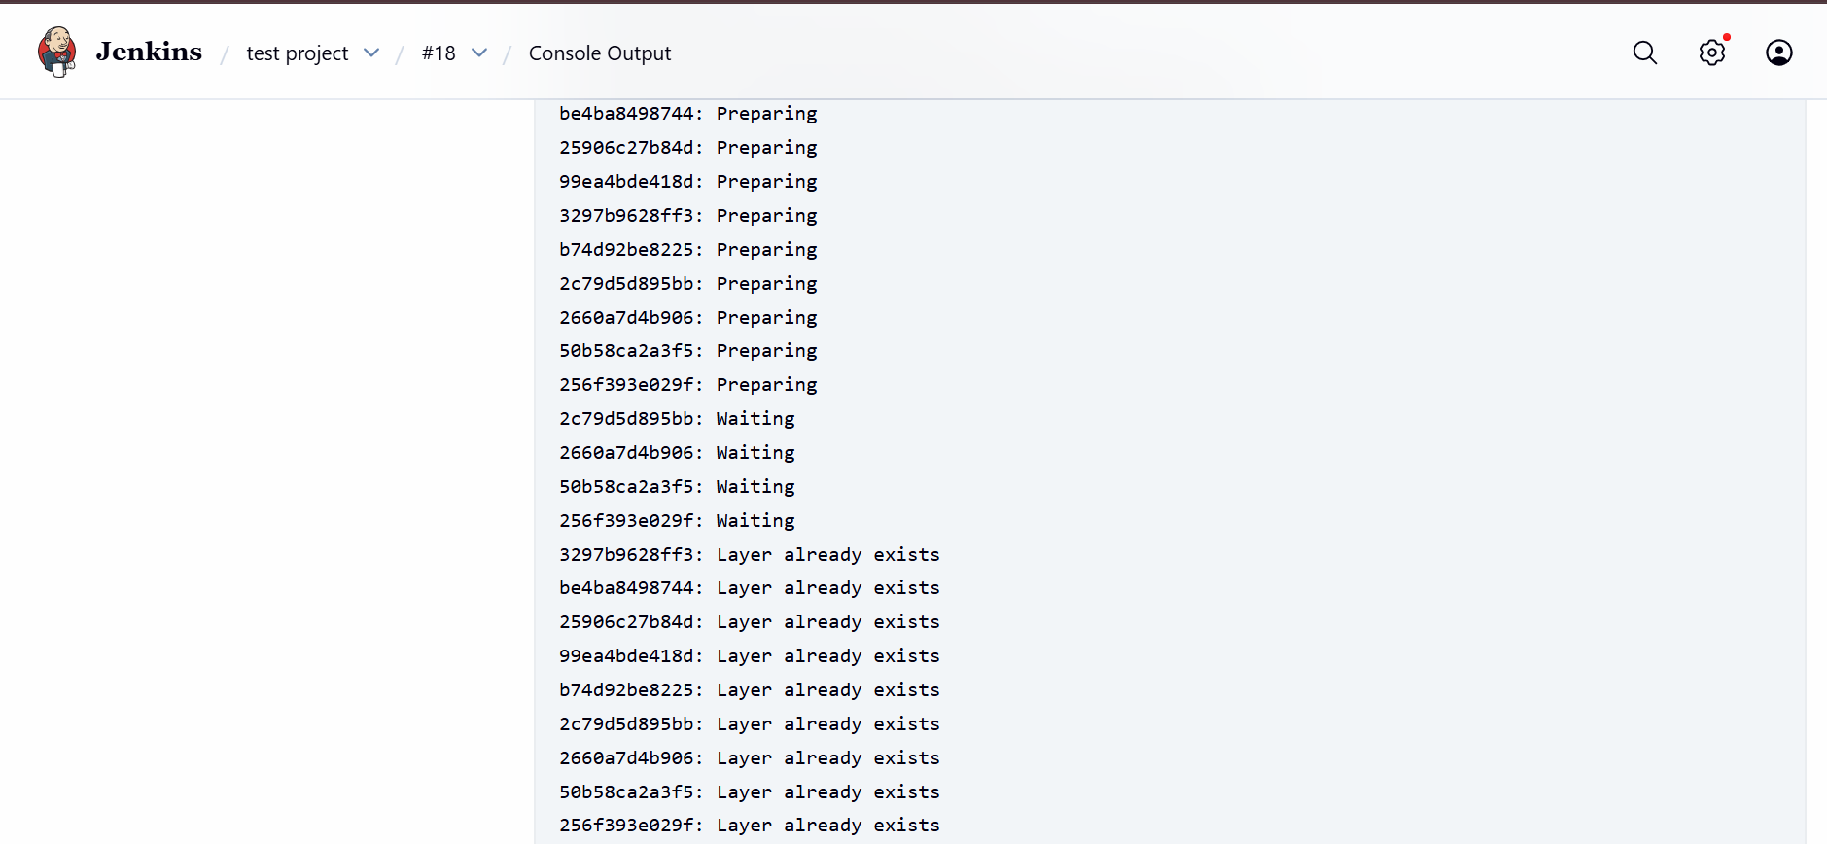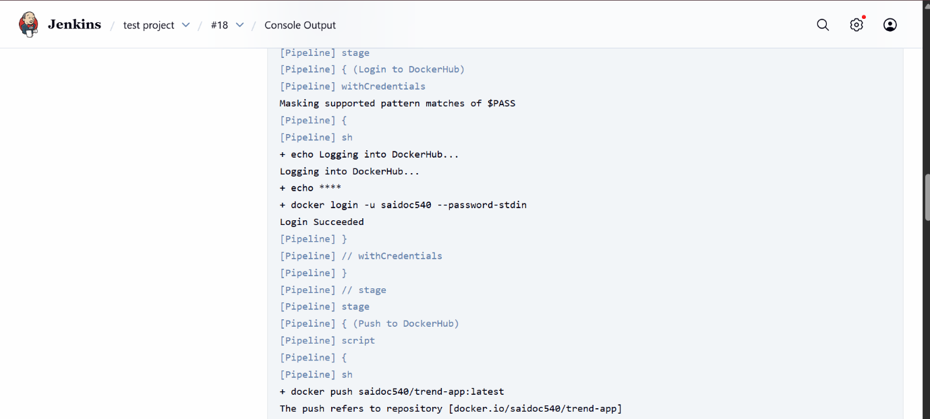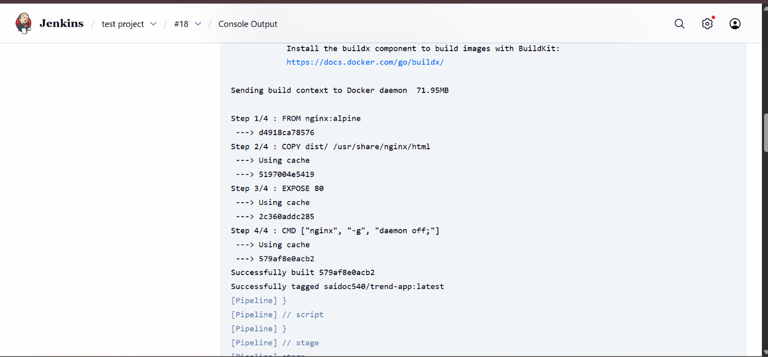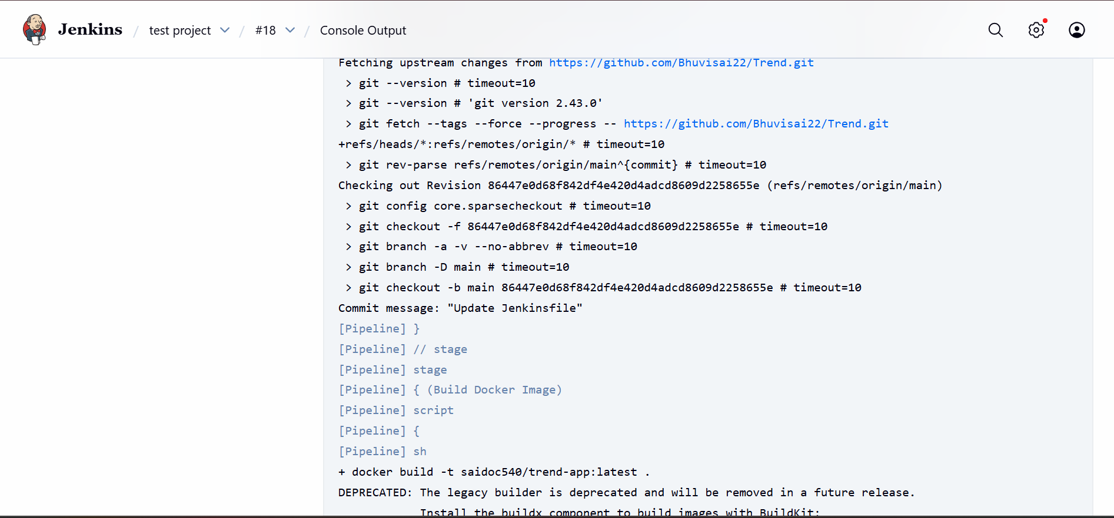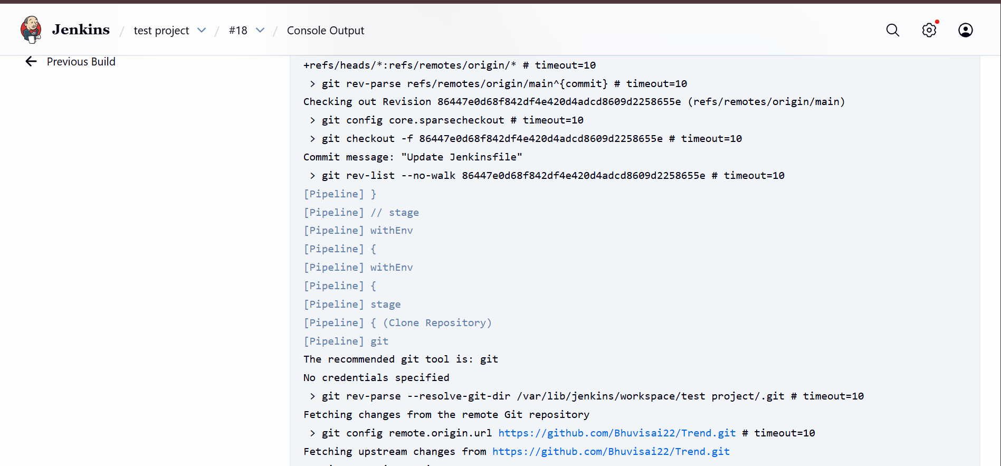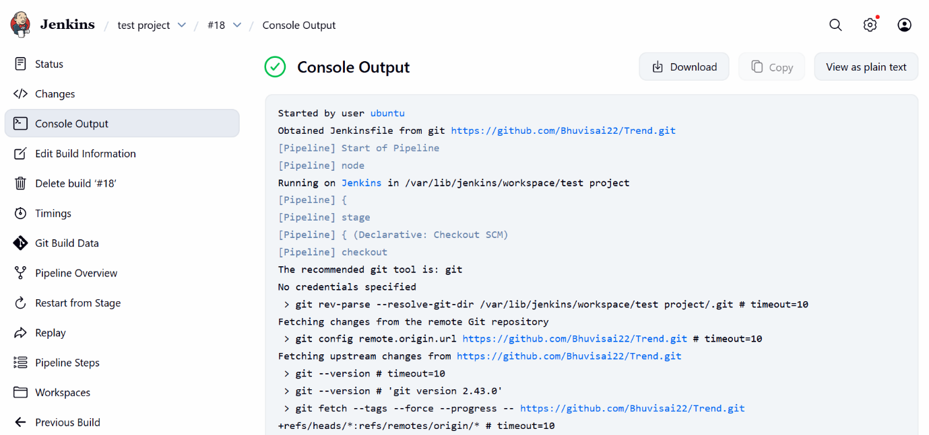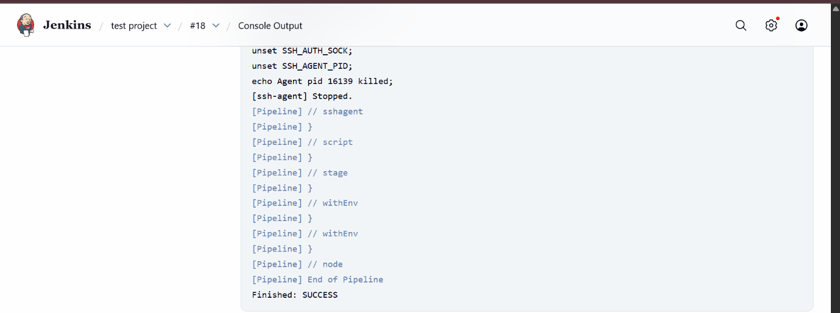
- Monitoring:
Setup a monitoring system to check the health of the cluster: (Uptime-Kuma)